Objective 1:

To sense the body temperature and pulse rate of the patient.

Components Required :-

- MLX 90614 Temperature Sensor.
- MAX 30102 Pulse Rate Sensor.
- Jumper wires.

Detailed Description of components:-

MLX 90614 Temperature Sensor:-

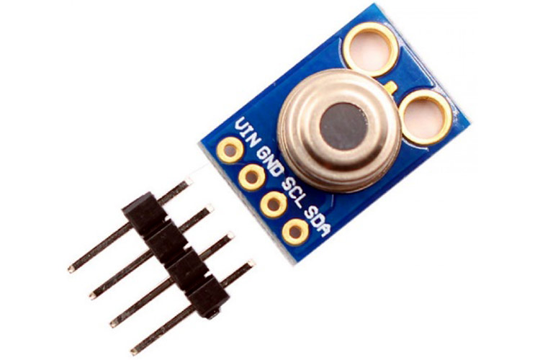
Infrared Non-contact Temperature Sensing Module - MLX90614
Product Description:-
The MLX90614 is a Contact less Infrared (IR) Digital Temperature Sensor that can be used to measure the temperature of a particular object ranging from -70° C to 382.2°C. The sensor uses IR rays to measure the temperature of the object without any physical contact and communicates to the micro-controller using the I2C protocol.

Module Features
- Works from 3.3V to 5V input, Module has power regulator IC built in.
- Standard I2C interface with built 2x pull up resistors
- Operating Voltage: 3V- 5V
- Operating Current: 2mA
- Communication protocol: I2C.
- Sensor working temperature: -40 to +125 Degree C
- Sensing temperature range: -70 to +380 Degree C
- When measuring the tempeature, please maintain a measuring distance of 1 cm
- PCB dimensions 11mm x 17 mm

Board Schematic:-
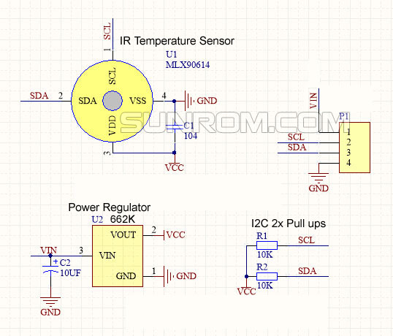

MLX90614 Pin-out Configuration:-
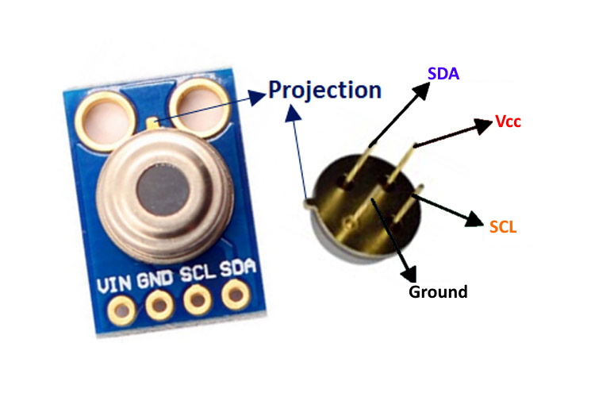
Pin No. | Pin Name | Description
1 | Vdd (Power supply) | Vdd can be used to power the sensor, typically using 5V
2 | Ground | The metal can also act as ground
3 | SDA – Serial Data | Serial data pin used for I2C Communication
4 | SCL – Serial Clock | Serial Clock Pin used for I2C Communication

MLX90614 Features and Benefits
- Small size, low cost
- Easy to integrate
- Factory calibrated in wide temperature range: -40 to 125 °C for sensor temperature and -70 to 380 °C for object temperature.
- High accuracy of 0.5°C over wide temperature range (0..+50 C for both Ta and To)
- Medical accuracy of 0.1°C in a limited temperature range available on request
- Measurement resolution of 0.01°C
- SMBus compatible digital interface for fast temperature readings and building sensor networks
- Customizable PWM output for continuous reading
- Simple adaptation for 8 to 16V applications
- Power saving mode
- Automotive grade
Applications:-
- High precision non-contact temperature measurements
- Thermal Comfort sensor for Mobile Air Conditioning control system
- Temperature sensing element for residential,commercial and industrial building air conditioning Wind shield defogging
- Automotive blind angle detection
- Industrial temperature control of moving parts
- Temperature control in printers and copiers
- Home appliances with temperature control
- Healthcare
- Livestock monitoring
- Movement detection
- Multiple zone temperature control – up to 127sensors can be read via common 2 wires
- Thermal relay / alert
- Body temperature measurement

Advantages of MLX90614 over other Temp sensors:-
- Our project is related to the medical field so we have to choose the temp sensor which gives good accuracy so MLX 90614 's accuracy is near about 0.02-degree c so it is far better than other temp sensors.
- It is a contact-less inferred temp sensor, so in this pandemic situation contact-less is the best option. It can sense the temp of an object from a distance of 2cm to 5cm approx.
- Its object temp range is near about -70 to 380 deg c . so it can sense the wide range of temp.
- MLX 90614 consumes low voltage and low current. Its operating voltage is near about 3 v to 5 v and the required supply current is near about 2 mA.

Arduino Connection:-
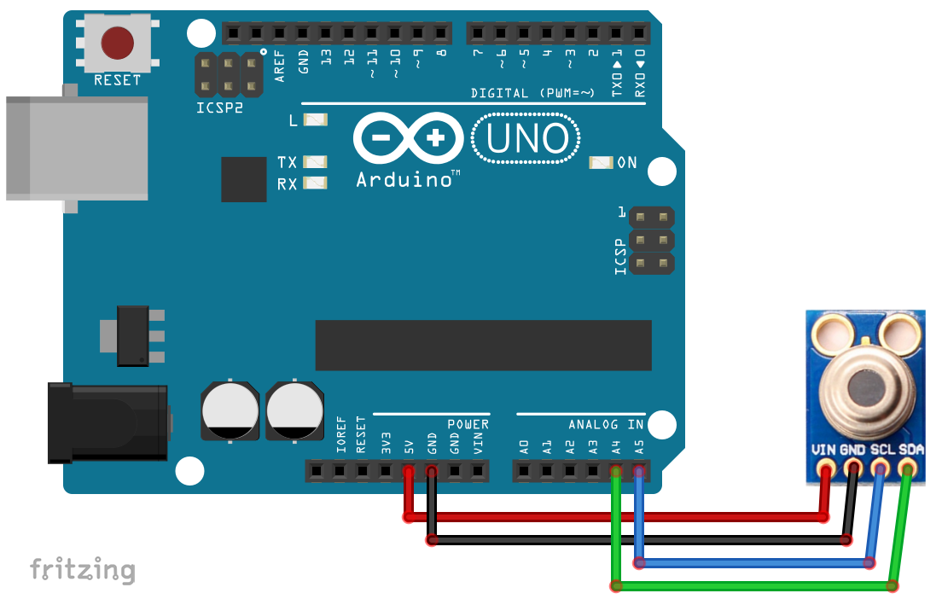

MAX 30102 Pulse Rate Sensor:-
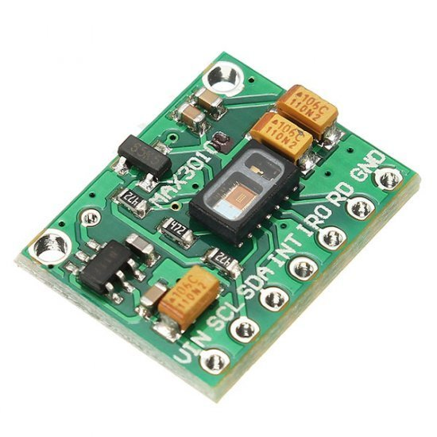
Product Description:-
The MAX30102 is an integrated pulse oximeter and heart rate monitor bio sensor module. It integrates a red LED and an infrared LED, photo detector, optical components, and low-noise electronic circuitry with ambient light suppression.- The MAX30102 features a 1.8V power supply and a separate 5.0V power supply for internal LEDs for heart rate and blood oxygen acquisition in wearable devices, worn on the fingers, earlobe, and wrist. The standard I2C-compatible communication interface can transmit the collected values ??to the , KL25Z and other micro controllers for heart rate and blood oxygen calculation.- In addition, the chip can also shut down the module through software, the standby current is close to zero, and the power supply is always maintained. Because of its excellent performance, the chip is widely used in the Samsung Galaxy S series mobile phones.- Compared with the previous generation MAX30100, the chip integrates a glass cover to effectively eliminate external and internal light interference, and has the best reliable performance. The Main Parameters: LED peak wavelength: 660nm/880nmLED power supply voltage: 3.3~5VDetection signal type: light reflection signal (PPG)Output signal interface : I2C interface-communication ` interface voltage: 1.8~3.3V~5V (optional)Board reserved assembly hole size: 0.5 x 8.5mm Pin Description: VIN: main power input terminal 1.8-5V3-bit pad: Select the pull-up level of the bus, depending on the pin master voltage, select 1.8v or 3_3v (this terminal contains 3.3V and above)SCL: the clock connected to the I2C bus;SDA: data connected to the I2C bus;INT : Interrupt pin of the MAX30102 chip;RD: RED LED ground terminal of MAX30102 chip, generally not connected;IRD: The IR LED ground of the MAX30102 chip is generally not connected;GND: Ground wire.
Pin description:

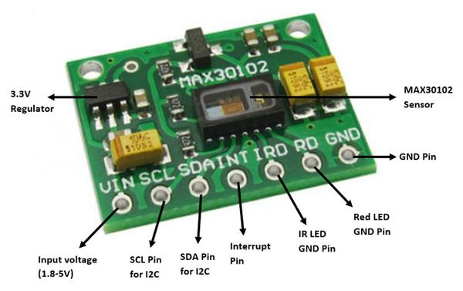

Pin No. | Pin Name | Description
1 | Vin | Main power supply input 1.8v-5v
2 | GND | Ground Wire
3 | SDA – Serial Data | Data connected to the I2C bus.
4 | SCL – Serial Clock | The clock connected to the I2C bus.
5 | INT | Interrupt pin of the MAX30102 chip.
6 | RD | RED LED ground terminal of MAX30102 chip , generally not connected.
7 | IRD | The IR LED ground of the MAX30102 chip is generally not connected.
8. | 3-Bit Pad | - -selects the pull-up level of the bus, depending on the pin master voltage, optional 1.8 v or 3.3 v end (this end contains 3.3 v and above).

Principle description:
Photo-dissolution method:
The measurement of pulse and blood oxygen saturation is performed by using human tissue to cause different light transmittance when the blood vessel beats.
Light source: A specific wavelength of light-emitting diode selective for oxyhemoglobin (HbO2) and hemoglobin (Hb) in arterial blood.
Light transmittance is converted into an electrical signal:
The change in the volume of the arterial pulsation causes the light transmittance of the light to change. At this time the light reflected by the human tissue is received by the photoelectric transducer, converted into an electrical signal, and amplified and output.

Specifications:
- Highly-integrated, small-size sensor
- Non-chest based heart-rate/SpO2 detection
- Ultra-low power consumption
- LED Peak Wavelength: 660nm/880nm
- LED Supply Voltage: 3.3~5V
- Interface: I2C Interface
- Operating Temperature Range: -40°C to +85°C
- Dimension: 20.3 x 15.2mm
- Weight: 1.1g

Advantages of MAX3102 in compare to other pulse rate sensor:-
● The MAX30102 integrates red and IR LEDs to modulate LED pulses for oxygen saturation (SpO2) and heart rate measurements.

● Space savings: Maintains a very small solution size without sacrificing optical or electrical performance; Integrates internal LEDs, photodetectors, optical elements, and low-noise electronics with ambient light rejection.

Arduino Connection:-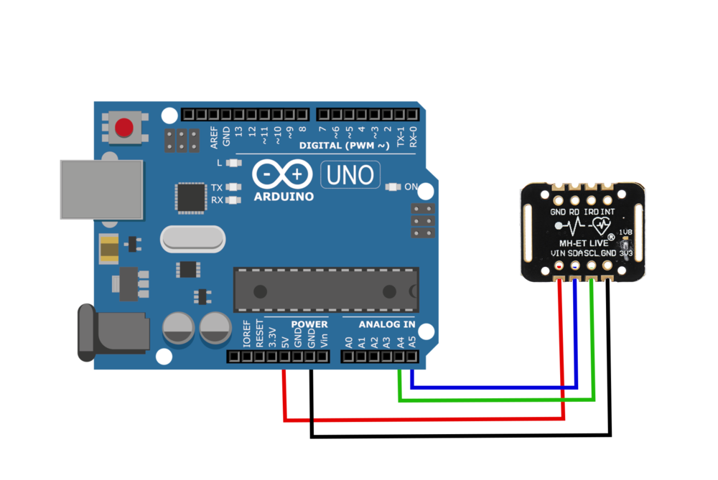

Flowdiagram:-(For patients parameters recording)
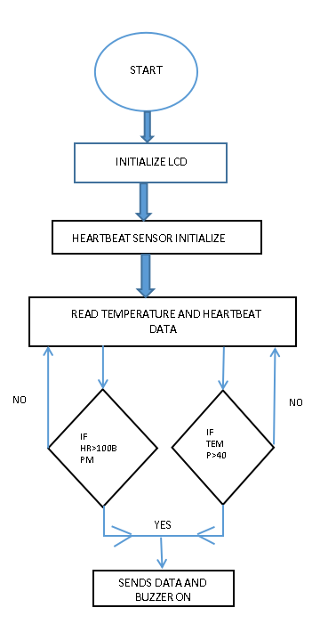

Objective 2:-
Development of a Wearable-Sensor-Based Fall Detection System for the aged people.

Components Required:-

- MPU6050 sensor board
- Jumper wires

MPU6050 - Accelerometer and Gyroscope Module:-
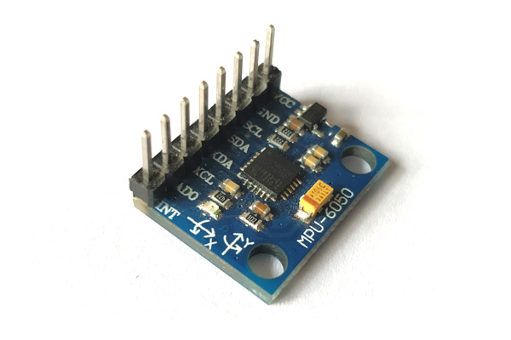
MPU6050 Module
Description-
The MPU6050 devices combine a 3-axis gyroscope and a 3-axis accelerometer on the same silicon together with an onboard Digital Motion Processor (DMP) capable of processing complex 9-axis MotionFusion algorithms.. This helps us to measure acceleration, velocity, orientation, displacement and many other motion related parameter of a system or object. This module also has a (DMP) Digital Motion Processor inside it which is powerful enough to perform complex calculation and thus free up the work for Microcontroller.
The module also have two auxiliary pins which can be used to interface external IIC modules like an magnetometer, however it is optional. Since the IIC address of the module is configurable more than one MPU6050 sensor can be interfaced to a Microcontroller using the AD0 pin. This module also has well documented and revised libraries available hence it’s very easy to use with famous platforms like Arduino. So if you are looking for a sensor to control motion for your RC Car, Drone, Self balancing Robot, Humanoid, Biped or something like that then this sensor might be the right choice.
Pin Description -

Pin Number | Pin Name | Description
1 | Vcc | Provides power for the module, can be +3V to +5V. Typically +5V is used
2 | Ground | Connected to Ground of system
3 | Serial Clock (SCL) | Used for providing clock pulse for I2C Communication
4 | Serial Data (SDA) | Used for transferring Data through I2C communication
5 | Auxiliary Serial Data (XDA) | Can be used to interface other I2C modules with MPU6050. It is optional
6 | Auxiliary Serial Clock (XCL) | Can be used to interface other I2C modules with MPU6050. It is optional
7 | AD0 | If more than one MPU6050 is used a single MCU, then this pin can be used to vary the address
8 | Interrupt (INT) | Interrupt pin to indicate that data is available for MCU to read

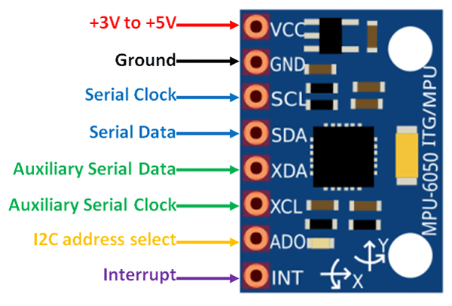
MPU6050 Pinout

How to Use MPU6050--
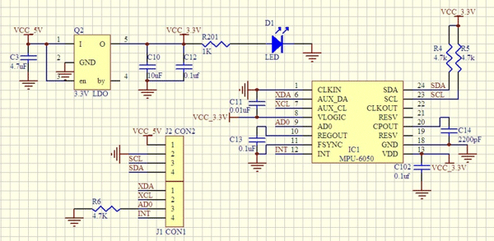

The hardware of the module is very simple, it actually comprises of the MPU6050 as the main components as shown above. Since the module works on 3.3V, a voltage regulator is also used. The IIC lines are pulled high using a 4.7k resistor and the interrupt pin is pulled down using another 4.7k resistor.

The MPU6050 module allows us to read data from it through the IIC bus. Any change in motion will be reflected on the mechanical system which will in turn vary the voltage. Then the IC has a 16-bit ADC which it uses to accurately read these changes in voltage and stores it in the FIFO buffer and makes the INT (interrupt) pin to go high. This means that the data is ready to be read, so we use a MCU to read the data from this FIFO buffer through IIC communication. As easy as it might sound, you may face some problem while actually trying to make sense of the data. However there are lots of platforms like Arduino using which you can start using this module in no time by utilizing the readily available libraries explained below

MPU6050 Features
- MEMS 3-aixs accelerometer and 3-axis gyroscope values combined
- Power Supply: 3-5V
- Communication : I2C protocol
- Built-in 16-bit ADC provides high accuracy
- Built-in DMP provides high computational power
- Can be used to interface with other IIC devices like magnetometer
- Configurable IIC Address
- In-built Temperature sensor

Interfacing MPU6050 with Arduino
It is very easy to interface the MPU6050 with Arudino, thanks to the library developed by Jeff Row-berg. You can download the library from the below link
Jeff Rowberg MPU6050 Library for Arudino
Once you have added this library to you Arduino IDE, follow the below schematics to establish an IIC connection between your Arduino and MPU6050

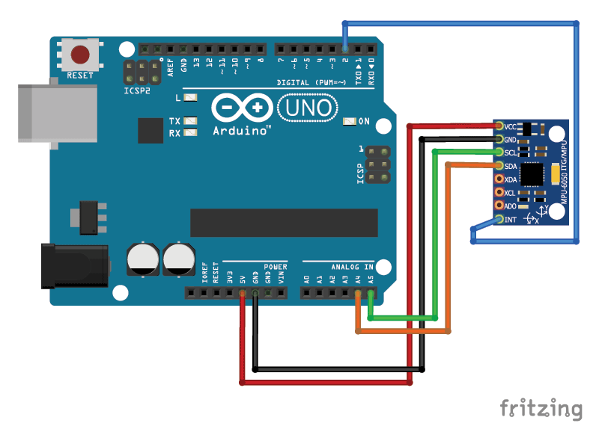
Interfacing MPU6050 with Arduino

Model Activity
Based on the fact that the direction of gravity is invariably perpendicular to the ground, and that the orientation of the vest worn on the body is supposed to be the same as that of the trunk, we use a Cartesian coordinate system OXYZ for the upper trunk, the origin of which is close to the neck of the human body, and is parallel with the geodetic coordinate system OXYZ, as shown in Figure 1.
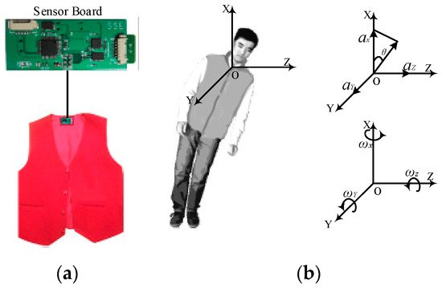
Figure 1. (a) The placement of the sensor board; (b) The geodetic coordinate OXYZ.
At a time t, accelerations along the X, Y, and Z axes are denoted as Ax(t), Ay(t) and Az(t) respectively, namely A(t) = {Ax(t), Ay(t), Az(t)}. The resultant acceleration α(t) can be calculated using Equation (1):
A(t)=

Since Ax(t), Ay(t) and Az(t) contain an approximation of the gravitational component of the acceleration on every axis, the trunk angle (namely θ(t)) can be calculated using Equation (2):
θ(t)=

The x-axis is perpendicular to the gravitational direction in the lying position and parallel to the gravitational direction in the standing position. A fall usually means that the trunk changes from a standing position to a lying position, and the θ(t) increases from about 0° to about 90°.
Meanwhile, the tri-axial angular velocities of the trunk can be collected by gyroscope. Wx(t), Wy(t), Wz(t) are the angular velocity at time t in the X, Y, and Z axes respectively, namely W(t) = {Wx(t), Wy(t), Wz(t)}. The resultant angular velocity W(t) can be calculated using Equation (3):

Data Acquisition
Figure 2 shows the sensor board, which is about 65 mm × 40 mm × 7 mm (length × width × thickness), and is appropriate for use in a vest. The sensor board contains a low-power microcontroller, and a class 2 Bluetooth module. The range of the Bluetooth module is 10 m, and its default transmission rate is 115,200 bps. The range of the tri-axial accelerometer is ±16 g. The full-scale range of the tri-axial gyroscope is ±2000°/s. The sampling data from the tri-axial accelerometer and gyroscope are read and transmitted to an Android smart phone.
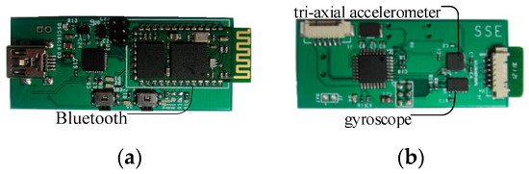
Figure 2. (a) Front of the sensor board with Bluetooth; (b) Back of the sensor board with tri-axial accelerometer and gyroscope.
Since most frequencies of human activities are less than 20 Hz, the sampling frequency from human activities is set to 100 Hz. The sensor board can acquire tri-axial accelerations and angular velocities, and send them directly to an Android smart phone.
Since falls are usually characterized by rapid acceleration and great angular velocity, four typical subcategories of ADLs and two kinds of falls are proposed in order to find out the difference between ADLs and falls. ADLs include Walking (Wk), Sitting down (Sd), Squatting down (Sq) and Bowing (Bw). Falls include Sideward fall (Sw-Fall) and Backward fall (Bw-Fall). Twenty healthy individuals, including ten males and ten females, aged 20–45 years were asked to do the simulated falls and normal ADLs, both outdoors and indoors. Each individual performs each of the six kinds of ADLs and falls—Wk, Sd, Sq, Bw, Sw-Fall and Bw-Fall—five times. Hence, the total experimental data set numbers 600 elements, which consists of six 100-element sets for Bw-Fall, Sd-Fall, Wk, Sd, Sq and Bw, respectively, with each one having the same sample length.

Flow Diagram(Fall Detection):-
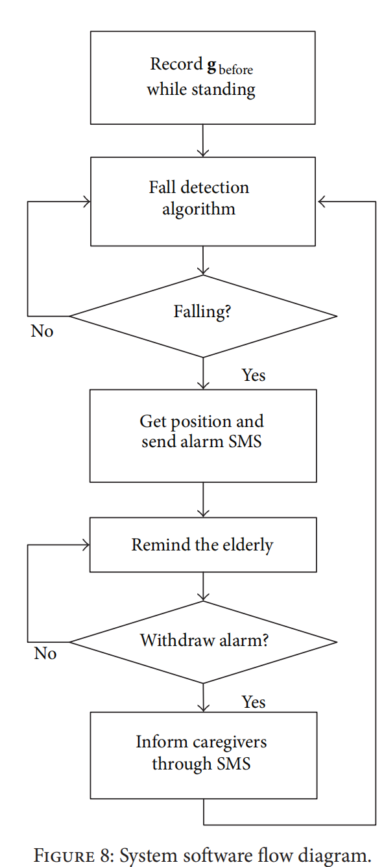

Overall Block Diagram:-

